# Document Engineering – Custom E Book

User Manual V1.0

Contents

**Introduction 3**

**Authoring tool 3**

Create Document 3

Choose Template 4

Document item buttons display 4

Preview of the Document 10

**Reader tool** 11

File open 11

Zoom Functionality **13**

**The tool installer 15**

# 

# Introduction

The project is designed to provide an author to create an interactive document on the authoring tool. The tool creates a package which is the input to the reader tool and the reader reads it in the format the author intends to show it.

# Authoring tool

## Create Document

When the author runs the authoring tool exe file, the below screen will be shown where he will have to enter the document name that he wants to create.

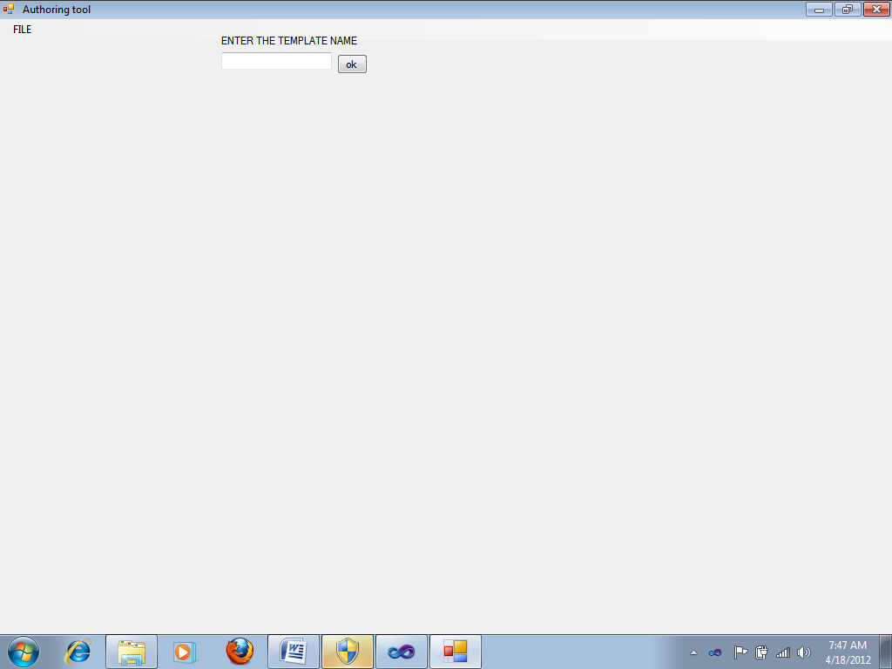

Once the author gives the document name, he would be asked to choose a Template .

## 

## Choose Template

Here the author depending on which template is apt for his document selects it.

The template choosing is as shown in the below screen shot.

## 

In the above screen shot. After clicking on the ok button of the “choose a template” pop-up, the author can choose any of the four templates shown above.

## Document item buttons display

Once the author selects a template, add item buttons will be highlighted depending on what template he chose. If the author chooses template 1, then the item buttons display is as shown below.

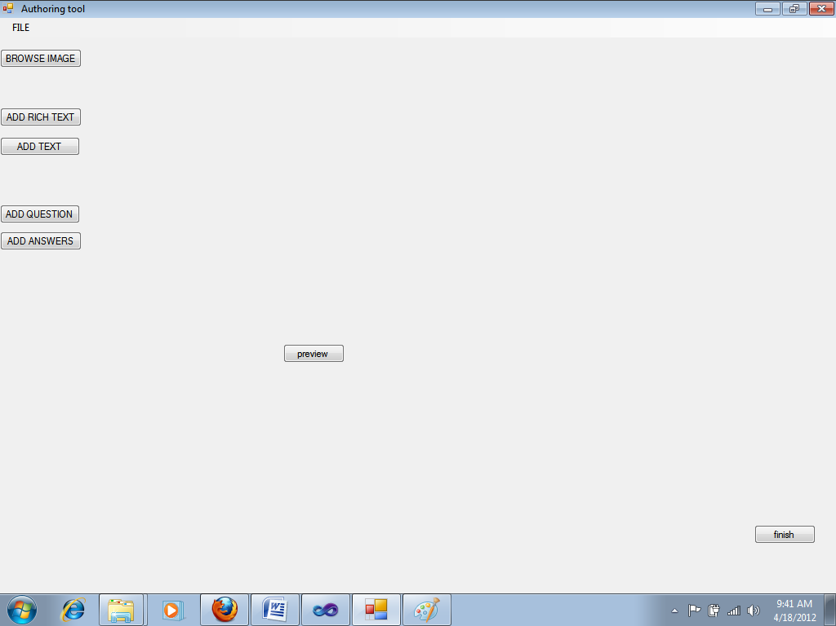

In the above screen shot it can be seen that, browse image button,add text button,add rich text button and question/answer buttons are highlighted.

When the author clicks on browse image button , the tool will look as shown below.

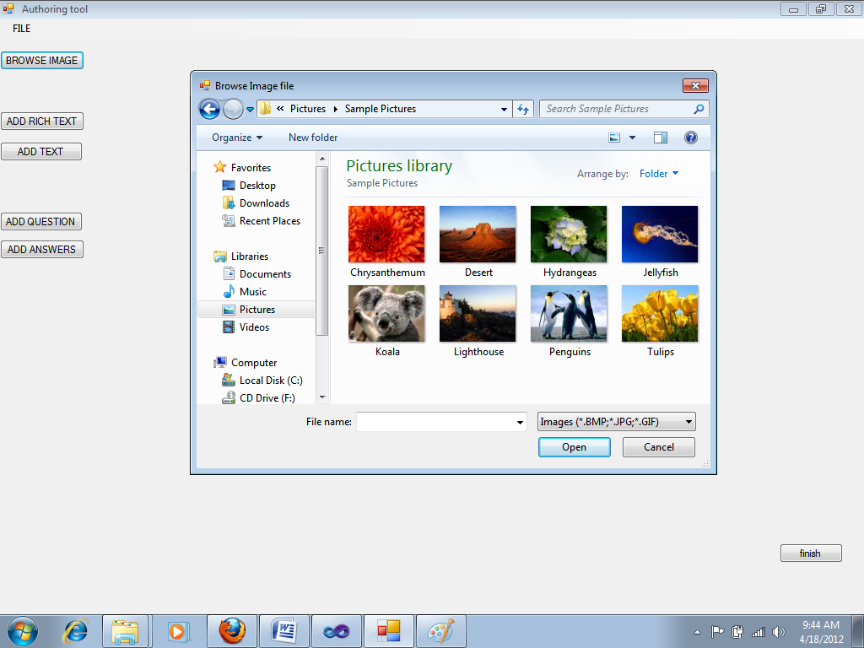

The author can choose whatever image he wants to display on his document by browsing through his image folder. Similarly he can browse for audio, video and flash files in other templates. If he clicks on the add text button, he will be allowed to add all the text he wants to show in his document.

If the author clicks on the add rich text button, the screen will look as follows

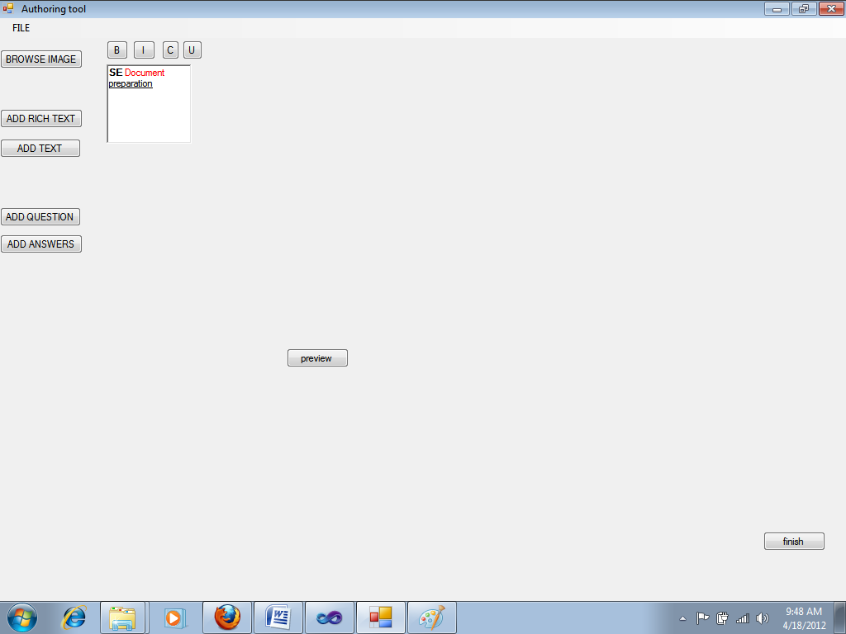

It can be seen on the above screen shot that the rich text editor gives author the option to display his rich text in four different options. He can make his text bold by clicking on the ‘B’ button or make it underlined by clicking on the ‘U’ button or coloured by clicking on the ‘C’ button or italicized by clicking on the ‘I’ button .

Then when the author clicks on the add question and answer buttons the display is as shown below.

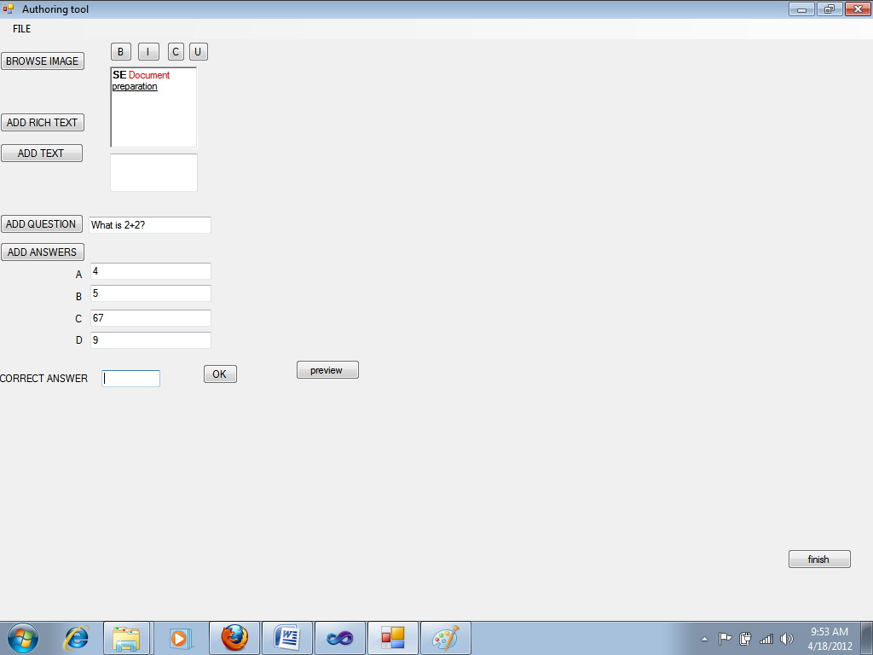

It can be seen that now the author is asked to enter the question and the four options for the question. The he is asked to enter the right option for the question. The author can enter either ‘A’ or ‘B’ or ‘C’ or ‘D’ in any case. If he writes anything else a warning is shown as in the below screen shot.

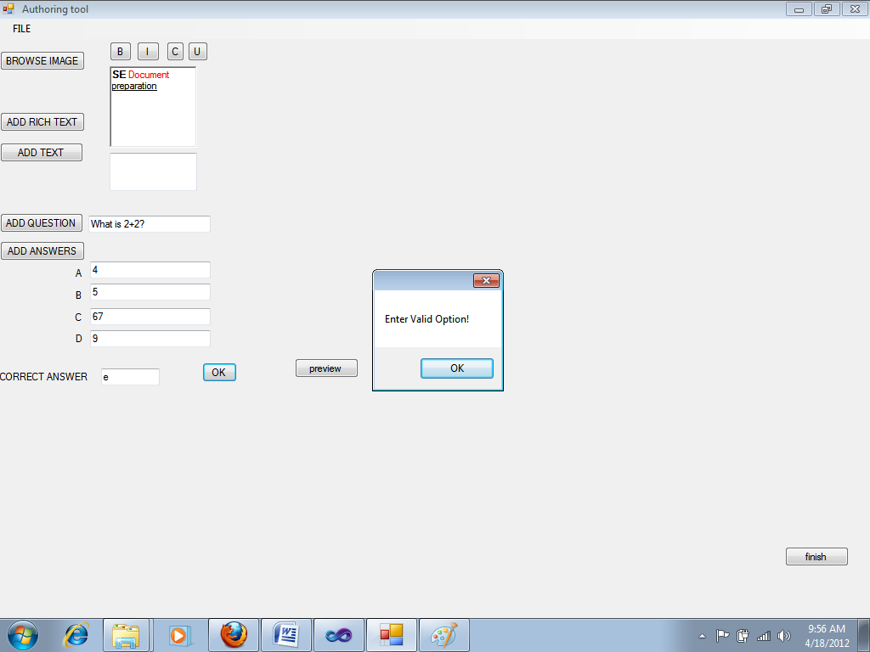

It can be seen in the above screen shot that the author entered ‘e’ which is not a valid option and hence the display of the pop-up Enter valid option.

After entering the valid option the author clicks on the OK button. Then by clicking on the preview button, the author gets to see how his document will be actually displayed. If he needs to make any corrections he can. The preview for the present template is as shown below.

## Preview of the Document

Once the author clicks on the preview button, it is shown as below.

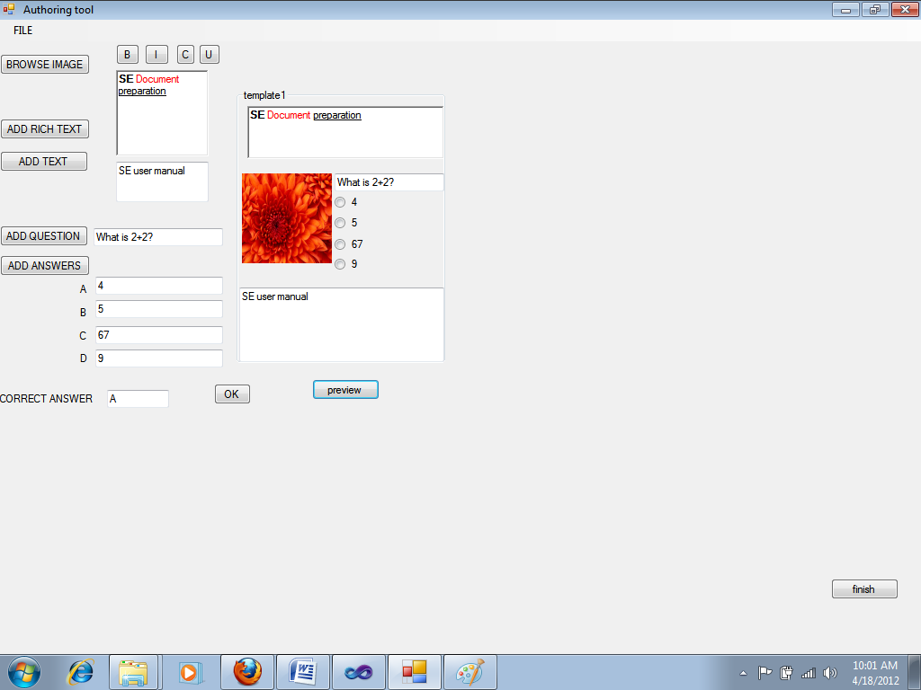

The above screen shot shows the preview of the document.

After seeing the preview, if the author is satisfied, he clicks on the finish button to create a package of his document.

This concludes the working of the authoring tool.

## 

# Reader tool

## File open

Here the reader chooses the document-package that he wants to read. The choosing as shown below

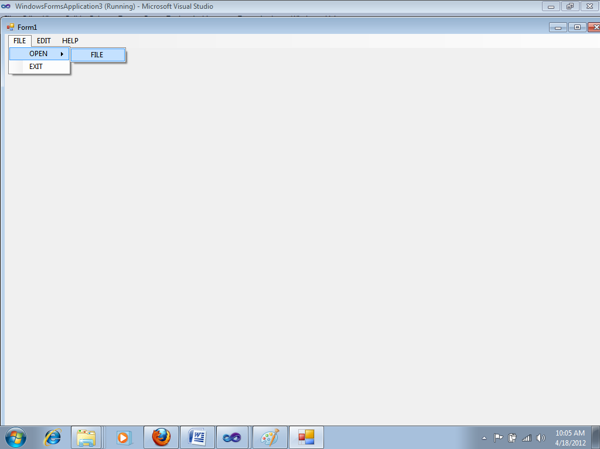

In the above screen shot it can be seen that the reader clicks on file-> open->file where he gets to choose the document he wants to read. The document browsing is as shown below.

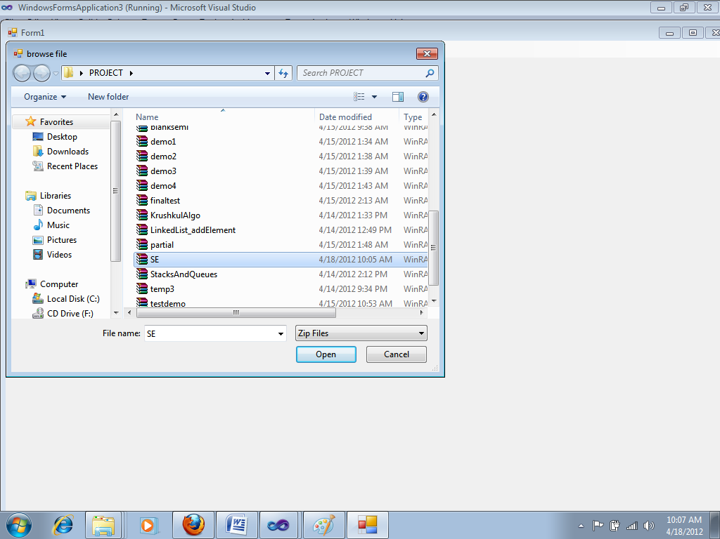

It can be seen in the above screen shot that the reader is choosing the document named ‘SE’ to read.

Once he clicks on ‘open’ button the document will be displayed as shown below.

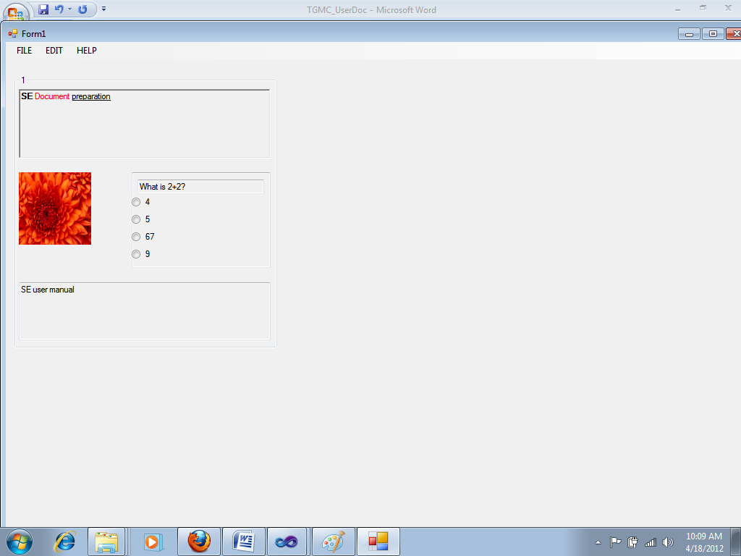

Now to view the document clearly the reader has to zoom it.

## Zoom Functionality

The reader needs to click on the edit -> font-> Zoom, which is shown in the below screen shot.

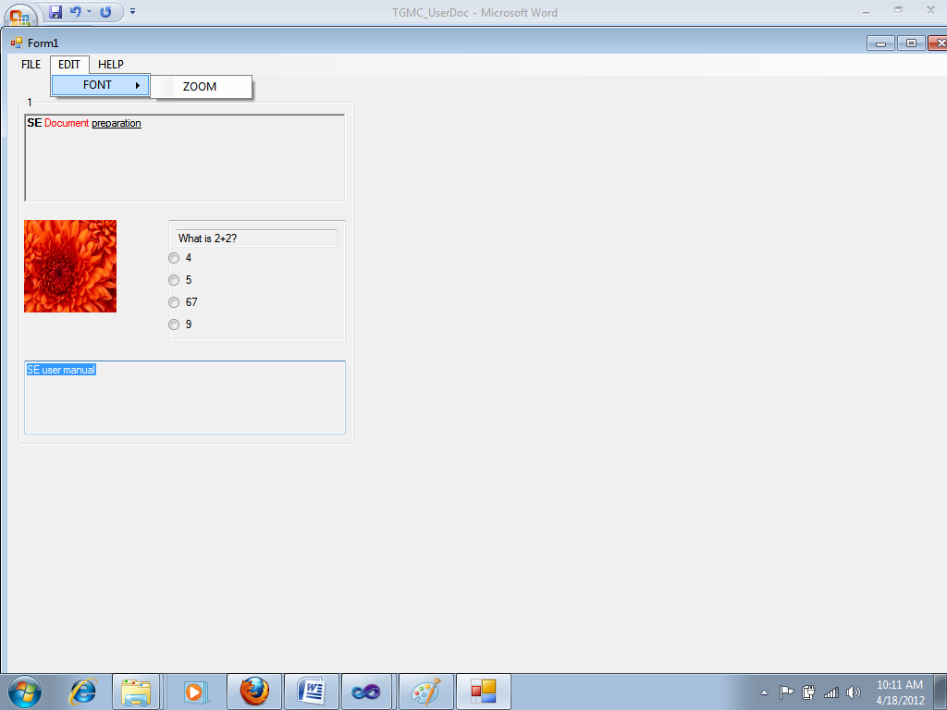

Once the reader clicks on the ‘zoom’ button the document is clearly visible to him as shown below.

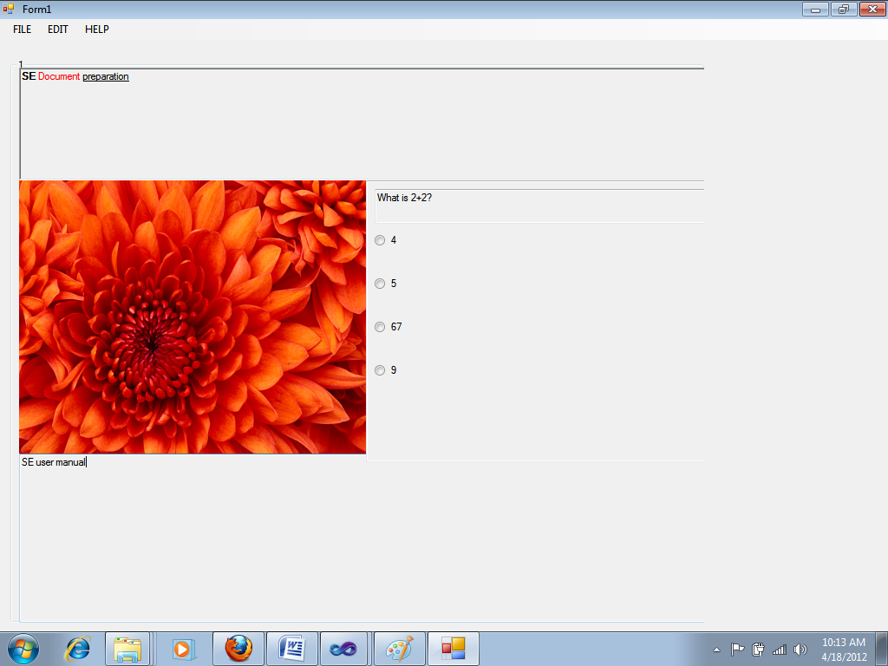

It can be seen in the above screen shot that the document is now clearly visible. Once the reader is done with reading the document he can close the document.

The following screen shot displays an useful document on krushkal’s algorithm. That has rich text, video, normal text and a quiz.

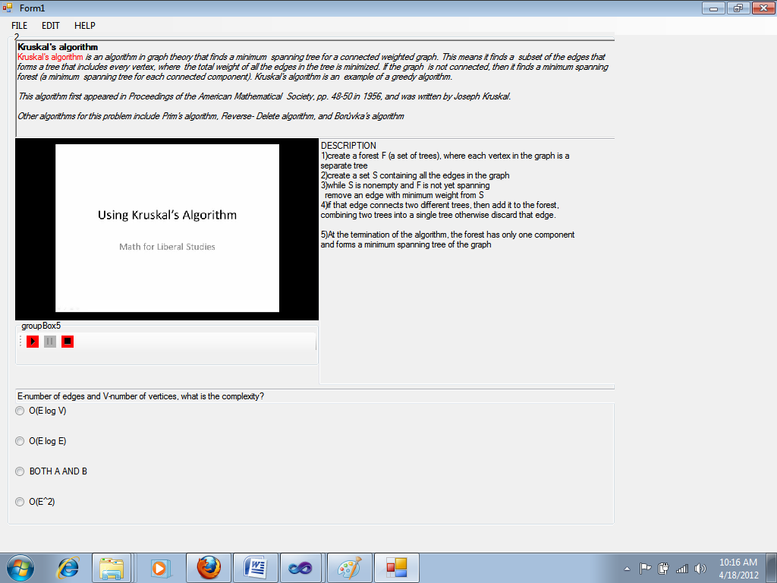

## 

# The tool installer

For both the tools exe files have been created. The installation for the reader tool is as shown below.

## 

The above screen shot is after clicking on the setup button. Once the user clicks the next button the setup wizard is as shown below.

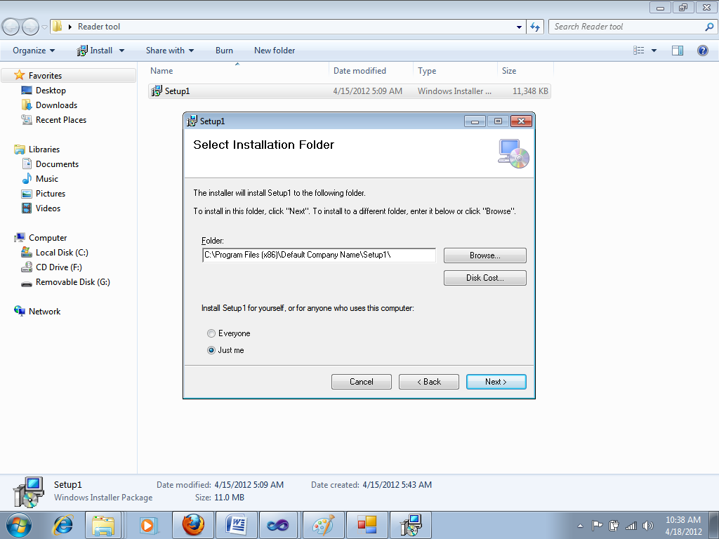

Here the author/reader needs to select the path where tool needs to get installed and he even needs to choose whether he alone or everyone else on this computer can use the tool.

On clicking next button the installation wizard will look as follows.

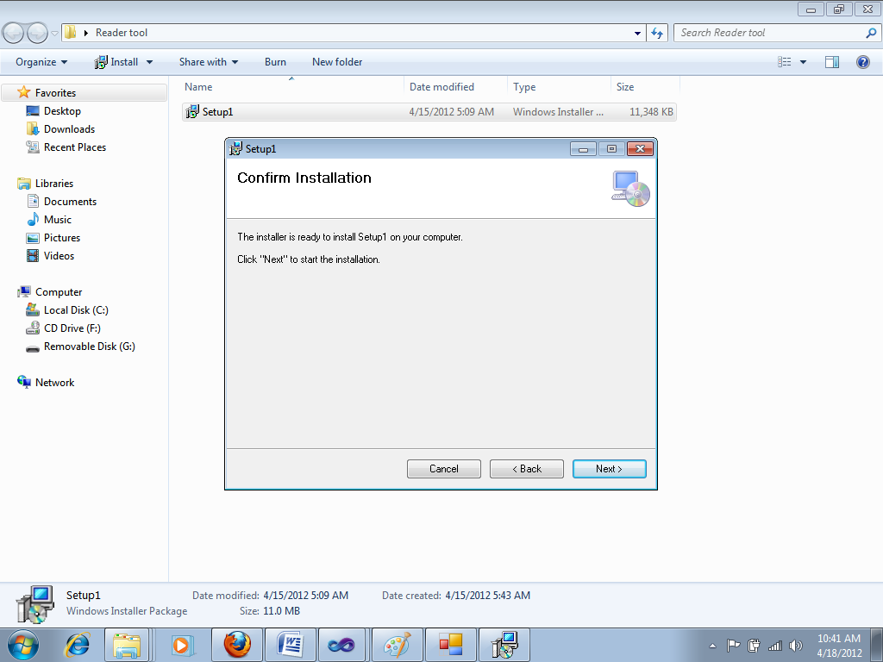

In the above screen shot it can be seen that the author/reader needs to click on the next button to confirm installation. After clicking the next button the installation of the reader/authoring tool starts. It is as shown below.

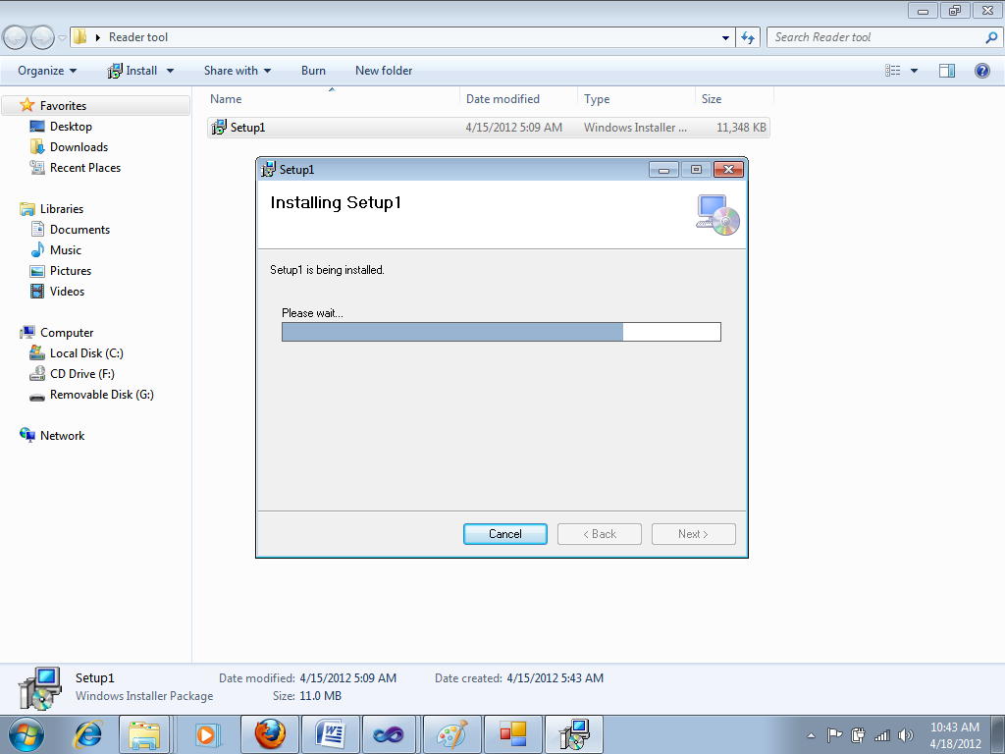

Once the installation is successful the wizard is as shown below.

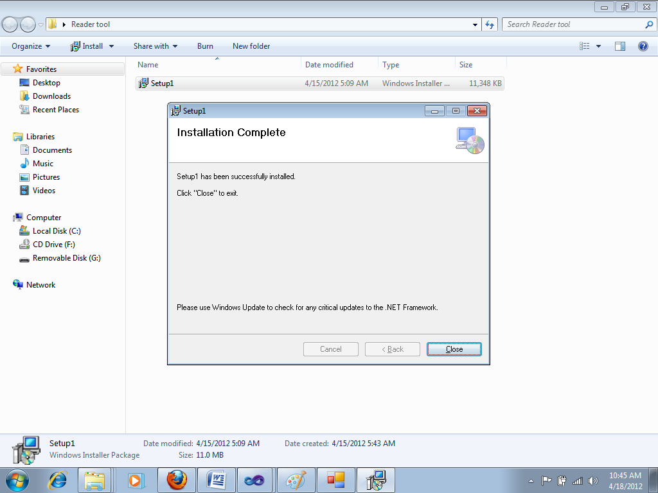

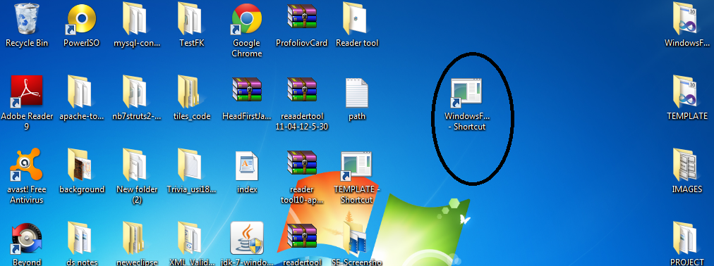

By double clicking on the circled shortcut, the reader tool can be directly opened now.

Similar procedure needs to be followed for the installation of the authoring tool.